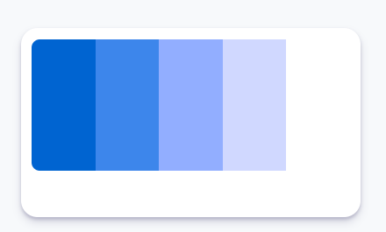.color1 {color: #0064d1;}

.color2 {color: #3d86eb;}

.color3 {color: #92aeff;}

.color4 {color: #d0d8ff;}

.color5 {color: #ffffff;}